# **Assignment 1: SQL**

Using the database from class, write queries to answer the following questions. For your submission, please submit the SQL query you wrote and your answer.

How many customers transact in a city other than their home city? You will need to find each customer’s Home Branch location and compare it to the location of their transaction (i.e. Transaction City).

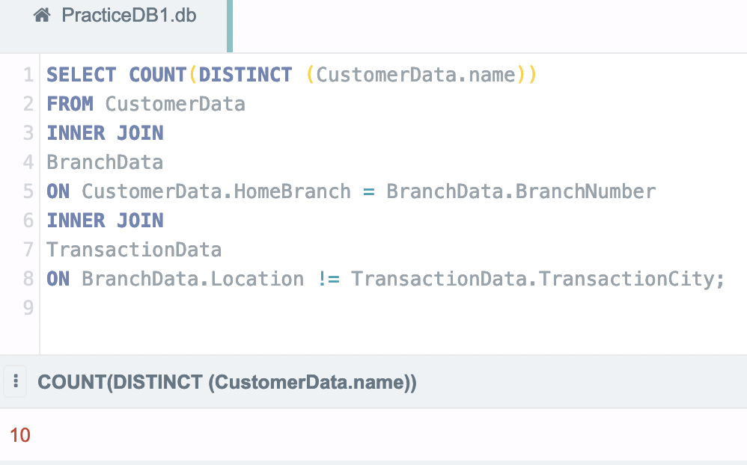

Which customers have the highest single transaction in each city?

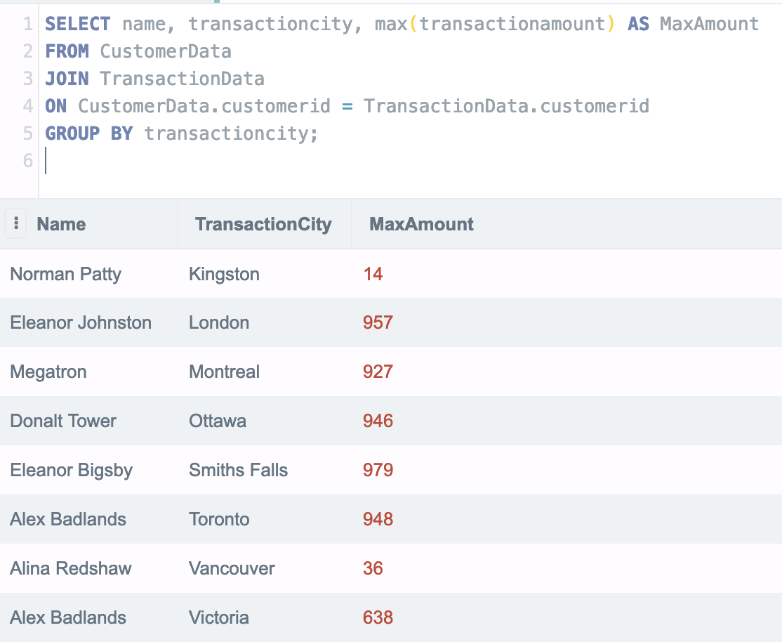

Which home branch holds the highest total customer account balances?

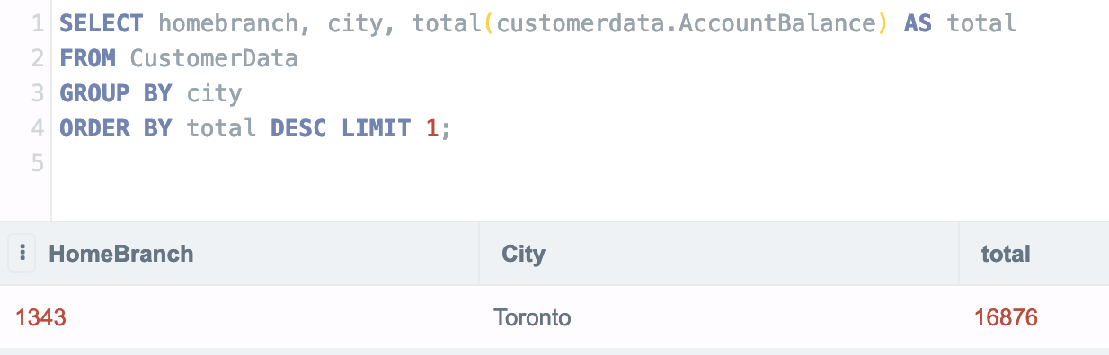

What is the average transaction amount in each category?

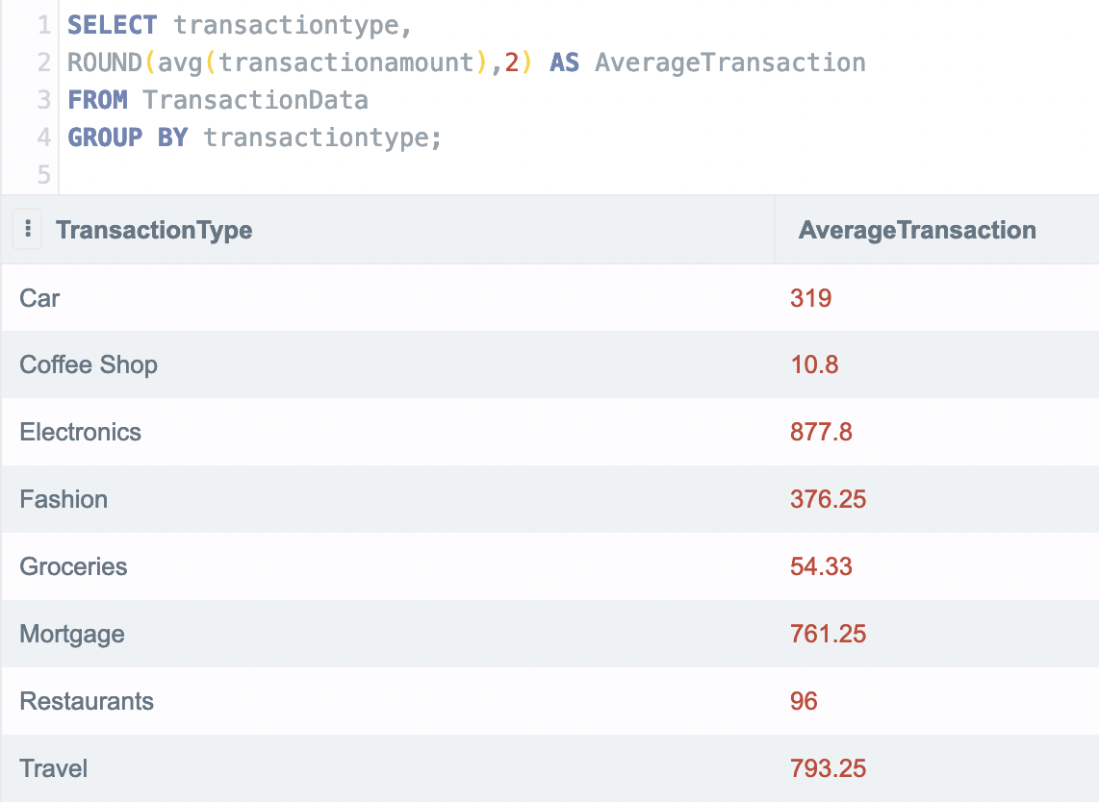

What is the range of transactions in each category? Range can be calculated by subtracting the Minimum transaction in a given category from the Maximum transaction in a given category.

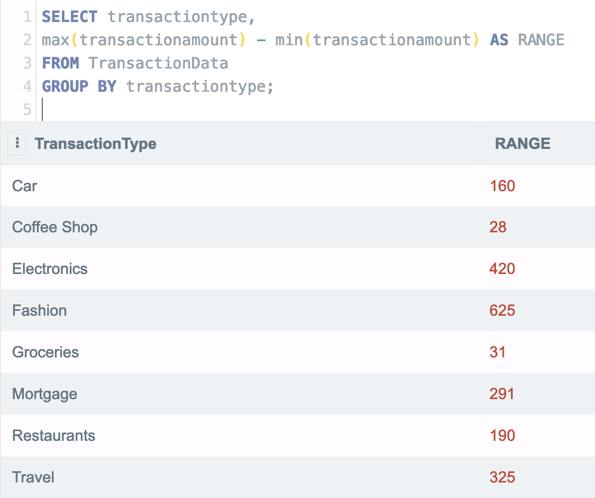

What is the total transaction amount by category, for transactions over $50 in the city of Toronto?

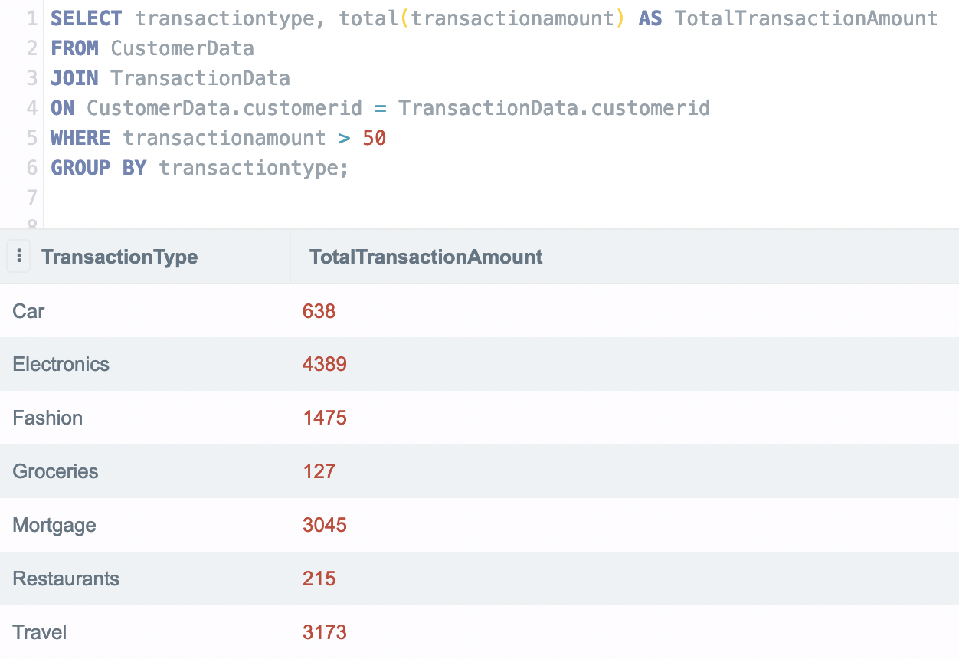

Which customers are the top 3 highest spenders (total transaction amount)?

